BathBot
“Cleans every surface of the bathroom and licks the bowl clean”

Product Innovation Case
Marketing Management & Customer Value - MKT 609
December 2018



The University of Tampa

Table of Contents
Introduction 2
Target Market selection 2
Targeting Option 6
Current Situation Analysis (SWOT) 6
Current company strategic position 8
The Marketing Mix 10
Control and Evaluation 12
Appendices 15
A: Charts and Images 15
B: Survey Results 17
C: Survey 20
D: Financial Projections 30
E: References 31

Introduction

Purpose of the project
The purpose of this projects is to determine the viability of a multifunction bathroom robot that can perform basic and advanced cleaning functions comparable or greater to human performance in the same task. The major factors and challenges directly related to a high-tech quality product that can replace human labor are cost and value. The value the integrated BathBot brings the customer must outweigh the higher price due to the cost of integration. BathBot’s strategy is to achieve differentiation advantage for a competitive advantage in the robot cleaning market. The strategic goal of our product is to usher in the next phase of household automation. The long-term goal is to develop household robots that can perform all household cleaning services using artificial intelligence (AI) to recognize what needs to be done.

Brief Situation Description
The household appliance industry is inundated with robot and automation devices to simplify the user experience. Currently, most household appliances are singularly focused; they perform one task. These household appliance robots can range in cost from $200 to $1,000 depending on the functionality and quality of performance they provide. In order to clean all surfaces and spaces in a bathroom, you would need to purchase a vacuum robot, mop robot, wall/glass robot, and a toilet robot. Aggregated, these products would cost in excess of $1,500 and take up a large amount of space and electrical outlets (See Appendix A). BathBot is the first robot that can clean multiple surfaces while being slightly larger than the current hard floor vacuum and provide assurance to the customer that those services are sterile with its integrated germ scanner.

Target Market selection

Segment Identification
The BathBot will be introduced in the U.S. and in Latin America since Latin America’s “have shown a world-leading appetite to engage with new digital tools. (Framil, 2018)” The product will be first introduced in Colombia with future opportunities of expanding worldwide. These two countries were chosen because of the increased use of robots in different scenarios and the potential they have for keeping things simple. When it comes to cleaning in the U.S., having someone to do it full time is expensive for middle income people as it costs $11.8 per hour (Occupational Employment and Wages, May 2017, 2017). Also, cleaning takes time, people are busy and lots people are buying robots such as the iRoomba Vaccuum, Braava Mop, Mirra Pool and the Mamibot window cleaner, which makes it an interesting segment to target and penetrate. On the other hand, testing the product in a country like Colombia, is a good way to measure its success in developing countries that are everyday wanting to be aligned with the most innovative technologies and trying to keep up with trends of other countries such as the U.S., which is always a referent for Colombians to explore different things.
Colombia is a country where labor is relatively cheap compared with other countries—the U.S. minimum wage is $7.25USD per hour and Colombia’s minimum wage is 781.242 Pesos, which is equivalent to $1.2 per hour when converting the local currency to USD. It is also very common to find domestic helpers in high-income family's that cook and clean the houses for them (Salario minimo para 2018 se definio en 781.242 pesos, 2017). There are around 750.000 domestic helpers in Colombia; however, this “privilege” that those people have, is becoming more difficult to sustain (Herrera, 2018). In 2018, the hiring rate for this service has dropped 8.7% (Herrera, 2018). The changes in living and market conditions is driving down the need for the domestic helpers. Many of the helpers have families that they don’t want to leave alone for an entire week, and they don’t want to work for the minimum wage that the labor ministry of Colombia requires. Also, they are asking for a high salary as well as other privileges while working such as having TV in their rooms, a cellphone, and access to internet. Another reason domestic helpers do not want to work full time is because they say that working part time in one place will allow them to have other jobs during the week and they can earn more money while working less hours (Varela, 2014).
Additionally, the employers are becoming more hesitant to employ these people because of the increased number of robberies and the requirements that the government has in terms of their contracts. The way the domestic helpers are hired is based on recommendations of other people, so it is difficult to know who you are hiring (El Dinero). So, understanding the situations mentioned above, is where the opportunity of proving a robotic bathroom cleaner presents itself for the Colombian market. They are used to having everything cleaned, and since it is becoming more difficult to hire the people to do it, there is a space and/or need that must be fulfilled when it comes to cleaning the bathroom.

Segment Description
Currently there are 126 million households in the United States. In the top two quintiles income mean is $99,030 and $221,846 respectively (Mislinski, 2018). Taking out the top 5% of income this segment represents 35%, or 44 million households. Of the 44 million households in the market segment that could easily purchase the BathBot, market penetration of households with age demographics between 18-44 and income levels of greater than $99,000 per year is approximately 15 million. A realistic market potential for U.S. households is $2,061,914,400.
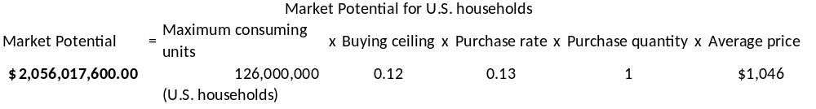
In 2017 there were 14 million households in Colombia with an average gross salary in 2018 of 42,039 in U.S. dollars (Average Salary Survey, Colombia, 2018). Approximately 18% of households fall into the purchasing power and demographic markets (DANE, 2018). Therefore, the market potential for Colombia households is $396,522,000.00.
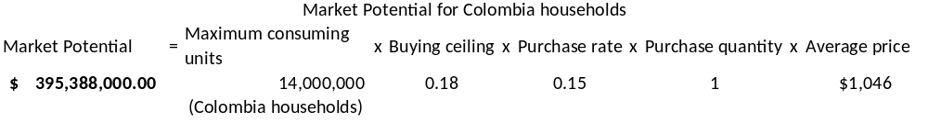
*This estimate is limited to only two countries. Expanding this out, market potential could double or triple taking into account European and Asian markets.

United States

Based on primary research conducted: individuals in the United States clean their bathroom, on average, 1-3 times in a given week (See Appendix B). The age bracket corresponding closest to 1-3 cleanings per week were 18-24 years-old bracket followed by the 25-32 years-old bracket (See Appendix B, Table 1). Also, if the same age groups were to purchase the BathBot then they would increase the frequency of cleaning to 6-9 times per week (See Appendix B, Table 2). Additionally, 46.2% of the 18-24-year-old bracket are extremely unlikely to hire someone to clean their bathroom, which indicates a stronger market demand for BathBot rather than paying for an equivalent service. Also, 23.1% of the 25-32 years-old bracket are extremely unlikely to hire someone to clean their bathroom followed by 57.1% who are neither unlikely or likely (See Appendix B, Table 3). This indicates potential for the BathBot’s success as it would fulfill their need of having their bathroom cleaned without having to hire someone. In the 18-24-year age bracket, 46.2% of respondents also indicated that they were extremely unlikely to hire someone in order to clean their bathroom (See Appendix B, Table 3).
The features that consumers indicated they want the robot to possess include a multiple surface cleaner/disinfector, a brush, a mop, vacuum, and germ detector; in that order of importance. There were other features that were included but did not represent significant features or values to the customer (See Appendix B, Table 4). Also, there is a strong positive correlation (0.34) between the age brackets and the price that the consumers in that age bracket are willing to pay for the BathBot. Older consumers are willing to pay more for the BathBot compared to younger consumers. Specifically, the age group of 25-32 would be willing to pay between $600-$800 for the BathBot robot, which is the price range that received the most responses (See Appendix, Table 5).

Colombia
After conducting a survey for high-income people in Colombia, 80% of the people surveyed in an age range of 25 to 38 years said that they clean their bathrooms 1 to 3 times a week and, 85% of the respondents in that age range, said that they would hire someone to clean it (Appendix B Table 6 & 7). Looking for the potential of people buying the Bathroom Roomba, we found that 88.9% of the people in this age range (25-38), also said that they would use a bathroom robot cleaning and 62% of the people surveyed in that age range said that they would be willing to pay between $600 to $800 dollars (Table 8). Also, the respondents indicated that they would want the product to possess a brush, multiple surface cleaner/disinfector, a mop, and a germ detector in that order of importance. Therefore, the BathBot has a potential niche market in Colombia that are of consumers that are willing to use and pay for the product.

Targeting Option

Selective segmenting
After conducting some research, it was found that the product should be targeted towards a very niche market segment. In the case of the U.S., high-income people in an age range of 18 to 32 years old were the ones that were more relevant in terms of potential users for the product. This market is normally in a stage of their lives where they move and live alone, to go to school, and are starting their professional life and are single. In the case of Colombia, the target market is also a niche in the high-income class but the age group changes to 25 to 38 years old. This change is because people there normally live with their parents until they finish school and start working so they don’t need to have the BathBot before that since there is someone that cleans the house since their parents are the ones who pay for it.

Current Situation Analysis (SWOT)

Strengths
This product will help promote a healthier lifestyle, due to the elimination of germs. It will also provide convenience since customers can use this additional time they have, to do other activities instead of cleaning their bathrooms. Within the robotic cleaning product segment, this product is innovative since no other competitor has a similar product that can do all the activities, which the BathBot does. It provides first mover advantage due to this and with being a niche market, it is easier to identify and target these customers more easily. Since the BathBot connects to a mobile app, it provides the convenience of using the product at anytime from anywhere as long as the individual is connected to the internet. The existing customer market for this product is a strength because more people are incorporating technology into their daily lives with the assistance of appliances where there was a growth of 349% between 2016 and 2017(IOT Analytics, 2017).

Weaknesses
This product has a high price point which makes it less accessible than other robotic cleaning products and therefore less people will be able to afford it. Due to the niche market segment, it is only targeting one segment and a specific age range. It can be easily replaced by either a person, like in the Colombian market, or by the absence of an alternative, like in the U.S. market. Product connectivity can also be affected if there is no internet connection which let the user connect to the product via the app. Given that the benchmark for manufacturing in this industry is China, it is necessary to establish a good relationship with supplier, but it can be time consuming because it is a new product (iRobot 10-K). Current government relations with China has also strained the development of partnerships with suppliers in China due to the increase of tariffs between the U.S. and China. Likewise, is the case for intermediaries because it is a new product without an established business relationship with them.

Opportunities
There is the possibility of increasing the product line with additional products and therefore, increasing the market share for this product. Additional features will permit expansion of the product line as well. Since this product is initially only being marketed in the U.S. and Colombia, it can be expanded into new and similar markets across the globe. Another possibility is to partner or sell the product to a competitor, given that there are similarities between products, for example Google has begun to collaborate with iRobot (Bedford, 2018). This product is being oriented towards consumers, so moving forward, it can also be developed into a business to business model. Based on the versatility of the product, it can also be expanded into security and defense alternatives because it can be developed to include other types of functions. With the increase of smart homes, there is the opportunity of increase with this market as well and stay in tune with the regulations that can come about with security and legal terms.
Threats
There are other robotic cleaning products on the market so there is the possibility that the competition is also developing a similar product or can imitate the characteristics of the product that we will offer. Early adopters of the product may not find the product as useful as they believed it to be, which could hinder the expansion of the product into other markets or additional product lines as well as the other consumer groups such as the laggards. This product is dependent on technological innovation and it could become obsolete if additional innovation develops too quickly, therefore lowering price points or other products with more features. Since the BathBot has remote capabilities, it can also store geographical information about the house which could have privacy concerns if someone were to obtain that information for other purposes.

Current company strategic position

Competitive position
The robotic cleaning segment has been established since 1985, for a diversity of reasons but it is mainly within the vacuum segment (Prassler, 2000). Therefore, it seems to be in more of a niche segment within the household robotic cleaning segment. The BathBot does not have current competitors within this niche market. Therefore, it would be able to successfully target a niche market in both countries.

SBU/product position (use the BCG or GE matrix)
This product requires a large starting investment for research and development and because it is a portion of two distinct existing markets (people who use robotic assistants or pay people to assist with household cleaning), it has the potential to have losses the first years of development of the market (Statista, 2018). Within the BCG matrix, it would be considered a question mark since its success in the marketplace is still uncertain.

Growth strategy (Ansoff)

Product development
The BathBot will be competing with a variety of robotic cleaning assistants that already exist within the market as separate products, and therefore it is the introduction of a new product in this market. Its advantage is the simplicity of having all the other existing products but additional features that are currently not being satisfied by any of the other products.

Identification of a Sustainable Competitive
The BathBot has a sustainable competitive advantage due to its differentiation advantage with its competitors. Although the product is offered at a purchase price which is higher than its competitors, it provides additional functionality which other household robot products have not incorporated into their products. There are several products, which can do several functions which the BathBot does, but no one item can provide all the functionalities in one convenient product. However, since it is a new product, there is no brand reputation established, which is a weakness; however, once it is developed in the long-run, then it will allow the BathBot to position itself even stronger than its competitors.

Objectives for New Marketing Plan
The marketing plan is aimed at creating product recognition, since this product is new to the market but can be a substitute for existing robotic cleaning assistance. Another objective will be to convert people who currently hire someone else to clean for them to invest in the product, given that they have disposable income and can afford the BathBot. Initially, this will permit a 29% of the existing market in order to establish sales and gain the trust of early adopters (Kärcher, n.d.). Within the U.S. market, this can be measured by the number of units sold and obtaining further information upon registration of the product. The U.S. market permits an easier conversion of customers who will substitute or add the BathBot to their cleaning routines. For the Colombian market, it may be more difficult since there is the possibility that clients may opt for purchasing the product elsewhere and bringing it back to Colombia instead of purchasing the product directly there.

The Marketing Mix

Product
The product that is going to be presented is a home cleaning solution, which falls into the robotics category. In this case the focus of house cleaning will be specific to cleaning the bathroom. This product will be called BathBot. It is a water-resistant robot which can detect different surfaces and level of germs. It contains a sensors system that allows it to go through all your bathroom, which allows it to be able to climb walls/windows and wash your bathroom as you never thought a robot could do. Also, based on consumer needs it contains a mop, a scrub, and multiple surface detector/disinfector. The benefit of having the BathBot is that you do not need to worry about having to clean your bathroom yourself, which is not a fun task to do. It contains an application where you can manage the robot, which is a convenient feature because you don’t need to be at home to do it, just program it anywhere you go at any time. You can schedule when to clean the bathroom, when it is working you could see where it is, see the level of germs that it had at the beginning and compare it at the end with little to no more germs.
The BathBot robot is currently in the pre-launch stage of the product life cycle where market research has been conducted in order to determine the needs and wants of the consumers. The market research was conducted in order to determine different price points that the product could be offered for in comparison to current cleaning vacuums that exist in the market. Also, consumers were asked for their willingness to pay for the features that they would want the product to offer in order maximize the value of it.

Place
Regarding the online market, for the U.S., the BathBot will be available online on its own website, Amazon and in other websites of partner stores that have e-commerce options such as Bed, Bath & Beyond or Best Buy. Over 80% of U.S. shoppers buy online at least once during the month (Smith & Anderson, 2016). In the case of Colombia, online stores of the partner retailers such as Fallabella, K-tronix, and El Exito would be the initial medium for selling the product. As seen in Appendix A, according to a Pew research study, roughly eight in ten Americans are online shoppers (79%) and nearly 15% shop on a weekly basis, which indicates the high usage of online mediums in order to purchase products (Online Shopping Trends of Americans, 2016). Also, this will ensure a continuous flow of sales, which will ensure a constant flow of cash for the firm.
For the U.S., specifically in retail stores, such as Bed, Bath & Beyond, and electronic stores for example Best buy and larger stores such as Costco or Walmart. In the case of Colombia, Home stores such as Fallabella, Home Center, electronic stores such as Ktronix and larger stores such as El Exito and PriceSmart. In terms of the distribution, the product will be transported and distributed through one of the logistics companies of each country.

Price
After conducting the primary research, the price of the BathBot that potential customers are willing to pay is between $600 and $800 dollars for both countries. Given that the BathBot is a multifunctioning, cleaning robot, it will be priced higher than the competition’s high-end product, iRobot Roomba i7+, given that it counts with more features than a multitude of products which separately does the activities that the BathBot does. The financial analysis which was done took into account the estimated market demand based on the utilization of a robot to assist with household cleaning, or the hiring of a person to do the cleaning for them, in association with the target market identified in the surveys, that 2.76% of the mid to high-range income bracket (for both the U.S. and Colombia) would purchase the BathBot (Appendix D). The purchase price is based on an analysis of the company’s margin (51.6%) and the channel’s margin (25%), in order to create a win-win situation for all the players involved. The purchase price will be set at $1,046 for both markets, after the analysis was done to account for product cost and margins. The financial analysis was done over a 5-year projection and its price schedule will remain constant throughout this time frame. The only exception which may affect the purchase price is the exchange rate and possible tariffs, and this is relative to both the U.S. and Colombian markets.

Promotion
The promotion strategy is a key aspect for the success of the product. The goal of the promotion strategy for the BathBot is to educate the target consumers on the multiple uses it has and how life can become easier without stressing about household chores or hiring someone to do the tasks. It also must create awareness among people and make them want to buy the product. By having a promotion strategy, it will build up support for the launch of the product. For that reason, the promotion strategy of the product will be very aggressive in social media where the target customers are—Facebook, Instagram, and YouTube specifically, publications of the stores that will have the product—magazines and brochures—their website and their social media, and in store-demonstration to show people how it works to make it a believable product. It is also important to have traditional advertising such as a TV presence with commercials, bus stops, billboards and newspaper.
The idea behind the social media presence is to beat our competitor, iRobot, that has 1.3 million followers on Facebook, 31.9 thousand on Instagram and 15 thousand subscriptions in YouTube. The idea is to get over this numbers during the first 5 years of the launch of the BathBot. It is also important to mention that the product will have promotion support in the after-launching period. It is important to maintain the visibility of the product even if it is not going to be aggressive, but the social media will continue and occasionally have publications in different media. Based on the strategic alliance which will be established with SC Johnson, an introductory promotion for the multi-purpose cleaning product within the BathBot will help promote both the products. This will create a direct marketing opportunity for both businesses, since they are both involved in the cleaning industry. SC Johnson will also gain market promotion with its association with a technologically advanced household appliance.

Control and Evaluation

Forecasting
In order to forecast sales of BathBot, we look to existing and forecasted sales of our nearest competitor, iRobot. From 2014 to 2017 iRobot sales grew by 87%. While year over year growth was not consistent, higher growth correlated to new product launches. The household robot industry has advanced beyond the early adopters/majority phase and is entering mainstream market. The opportunity for sales in a high growth market, as well as not having the costs of a market leader, gives BathBot a differentiation advantage.
The best-case scenario for sales assumes that our product successfully integrates technology for the BathBot and delivers a superior product to market that our competitors cannot deliver. Through our advertising and marketing, customers see the value our product delivers, and they are willing to pay a premium for our product. BathBot reinforces its value through ease of use and proven performance. The BathBot assures customers through the germ scanner that the bathroom is clean, sterile and contributing to a healthy living environment. Realistic forecast of success is that the BathBot successfully integrates technology but it’s higher price point limit’s sales the first two years. Successful customer and critic reviews demonstrate the BathBot is the best product on market as far as functionality, versatility and assurance the customers bathroom is clean with its germ detector. Consumers are convinced that the value of the BathBot exceeds the cost and is worth the investment.

Financial Projections and Budgets

Delineation of costs
Cost challenges primarily come from engineering and software costs associated with integration of existing technology into one hardware platform. Currently iRobot’s cost of product revenue is about 49% (iRobot 10-K). BathBot will initially have 34% cost of product revenue, as production and integration costs will be higher than iRobot’s.

Estimates of Sales and Revenues
In this high growth market, demand is the highest factor in sales growth. Appendix D provides an estimate of projected revenues, costs or revenue, gross margin, research and development and selling and marketing costs. Projections were based off of our estimated marketing potential. Percent of revenue estimated by the cost areas were derived from the iRobot 10K report, with the BathBot reflecting slightly higher costs and lower margins due to our product and company being new. The product revenue and costs are for the BathBot product only and does not include other company costs and revenues. Continuous monitoring and marketing performance measures will ensure that these revenue projections and cost estimates are accurate. Purchase price was based off of market demand and competitor cost in combination with additional features and value BathBot brings to the customer.

Summary and Conclusion
Current consumer demand has moved towards technological advances in household appliances and the internet of things smart homes (Karcher, 2018). The BathBot integrates a variety of existing products into one autonomous robot with additional features based on surveyed consumers’ wants and represents the trend towards autonomous robotic assistants to everyday life. The value that this product creates for consumers is an alternative use of their time for more enjoyable activities, improved quality of life by living in a cleaner environment and reducing germs.

Appendices

A: Charts and Images
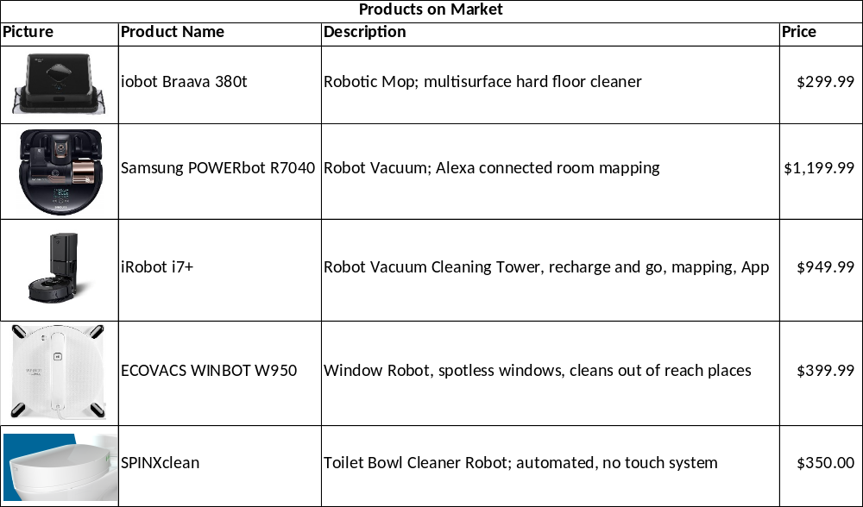
Prices from www.amazon.com
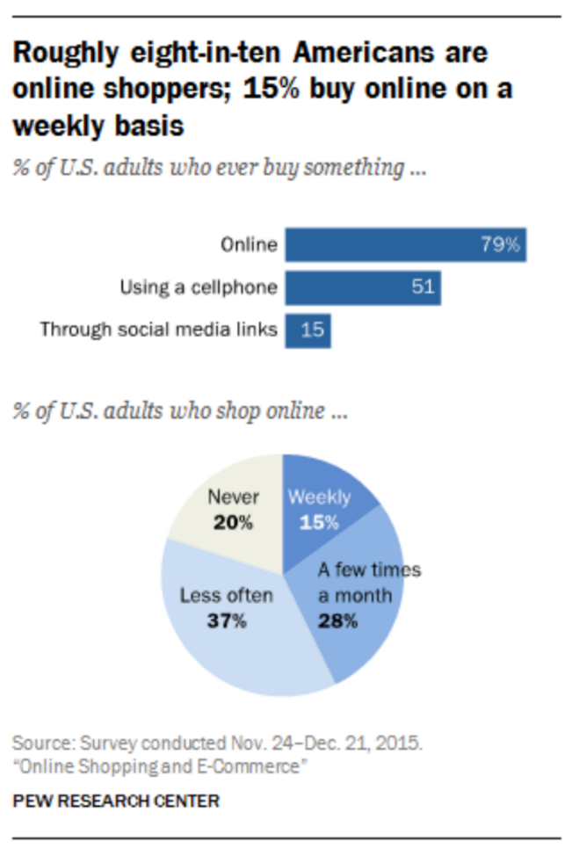
http://www.pewinternet.org/2016/12/19/online-shopping-and-e-commerce/pi_2016-12-19_online-shopping_1-01/

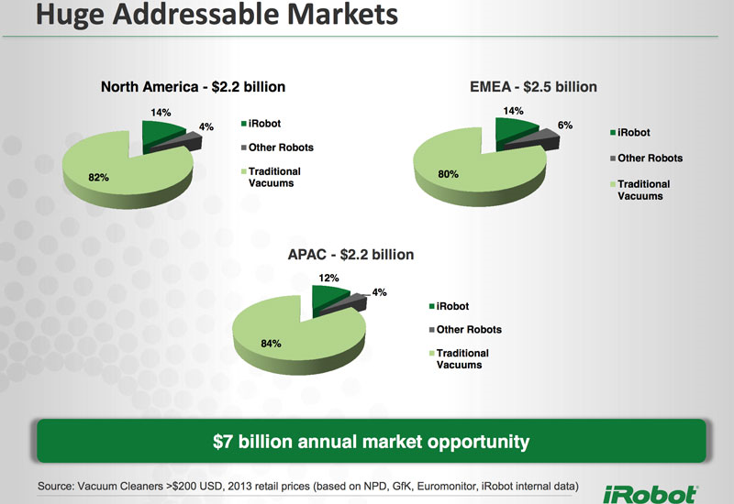

B: Survey Results
U.S
Table 1: Crosstabulation Between Cleaning Frequency and Age Group
How many times on average do you  clean your bathroom in any given week? | What age group do you best fit into? |  |  |  |  | Total
 | 18-24 | 25-32 | 33-38 | 39-44 | 44+ | Total
Less than 1 time | 4 | 4 | 3 | 0 | 1 | 12
1-3 times | 12 | 6 | 5 | 2 | 3 | 28
4-6 times | 1 | 1 | 0 | 1 | 1 | 4
7-10 times | 0 | 0 | 1 | 0 | 0 | 1

Table 2: Crosstabulation Between Frequency and Age Group |  |  |  |  |  | Total
Compared to your regular bathroom  cleaning frequency, if you have the robot, how many more times would you clean it? | What age group do you best fit into? |  |  |  |  | Total
 | 18-24 | 25-32 | 33-38 | 39-44 | 44+ | Total
The same amount | 2 | 2 | 2 | 1 | 2 | 9
1 time | 0 | 4 | 1 | 1 | 0 | 6
1-3 times more | 7 | 3 | 3 | 1 | 1 | 15
4-6 times more | 4 | 2 | 2 | 0 | 2 | 10
7-10 times more | 4 | 0 | 1 | 0 | 0 | 5

Table 3: Crosstabulation Between Age Group and Likeliness to Hire Someone
What age group do you best fit into? |  | How likely are you to hire someone in order to clean your bathroom?
What age group do you best fit into? |  | Extremely  likely | Somewhat  likely | Neither likely  nor unlikely | Somewhat unlikely | Extremely unlikely
18-24 | Count | 4 | 6 | 1 | 0 | 6
18-24 | % | 57.1% | 40.0% | 14.3% | 0.0% | 46.2%
25-32 | Count | 0 | 3 | 4 | 1 | 3
25-32 | % | 0.0% | 20.0% | 57.1% | 33.3% | 23.1%
33-38 | Count | 2 | 4 | 1 | 0 | 2
33-38 | % | 28.6% | 26.7% | 14.3% | 0.0% | 15.4%
39-44 | Count | 0 | 1 | 0 | 1 | 1
39-44 | % | 0.0% | 6.7% | 0.0% | 33.3% | 7.7%
44+ | Count | 1 | 1 | 1 | 1 | 1
44+ | % | 14.3% | 6.7% | 14.3% | 33.3% | 7.7%
Total | Count | 7 | 15 | 7 | 3 | 13
Total | % | 100.0% | 100.0% | 100.0% | 100.0% | 100.0%

Table 4: Features Ranked in Order of Importance for Consumers of the U.S.
Feature | Frequency | Percent | π (95% confident) | Confidence Interval
Multiple Surface Cleaner or Disinfector | 39 | 87% | 0.10 | 0.768 | 0.966
Brush | 35 | 78% | 0.12 | 0.657 | 0.899
Mop | 30 | 67% | 0.14 | 0.529 | 0.805
Vaccuum | 30 | 67% | 0.14 | 0.529 | 0.805
Germ Detector | 29 | 64% | 0.14 | 0.504 | 0.784
Automatic Dirt  and Dust Dispenser | 27 | 60% | 0.14 | 0.457 | 0.743
Soap Dispenser | 18 | 40% | 0.14 | 0.257 | 0.543
Sponge | 15 | 33% | 0.14 | 0.195 | 0.471

Table 5: Crosstab Between Age Group and Willingness to Pay
What age group do  you best fit into? | What price range would you be willing to  pay for the bathroom robot cleaner? |  |  | Total
What age group do  you best fit into? | Less than $600 | $600-$800 | $900-$1200 | Total
18-24 | 10 | 6 | 1 | 17
25-32 | 7 | 2 | 2 | 11
33-38 | 6 | 3 | 0 | 9
39-44 | 2 | 0 | 1 | 3
44+ | 3 | 0 | 2 | 5
Total | 28 | 11 | 6 | 45

Colombia
Table 6: Crosstabulation Between Age Group and Frequency of Cleaning One’s Bathroom
What age group do you best fit into? |  | How many times on average do you  clean your bathroom in any given week?
What age group do you best fit into? |  | Less than 1 time | 1-3 times | 4-6 times | 7-10 times
18-24 | Count | 0 | 1 | 0 | 0
18-24 | % | 0.0% | 6.7% | 0.0% | 0.0%
25-32 | Count | 1 | 10 | 6 | 1
25-32 | % | 100.0% | 66.7% | 75.0% | 100.0%
33-38 | Count | 0 | 2 | 1 | 0
33-38 | % | 0.0% | 13.3% | 12.5% | 0.0%
39-44 | Count | 0 | 2 | 0 | 0
39-44 | % | 0.0% | 13.3% | 0.0% | 0.0%
44+ | Count | 0 | 0 | 1 | 0
44+ | % | 0.0% | 0.0% | 12.5% | 0.0%
Total | Count | 1 | 15 | 8 | 1
Total | % | 100.0% | 100.0% | 100.0% | 100.0%

Table 7: Crosstabulation Between Age Group and Likeliness of Hiring Someone to Clean Their Bathroom
What age group do you best fit into? |  | How likely are you to hire someone to in order to clean your bathroom? |  |  | Total
What age group do you best fit into? |  | Extremely Likely | Somewhat Likely | Neither Likely nor Unlikely | Total
18-24 | Count | 1 | 0 | 0 | 1
18-24 | % | 7.1% | 0.0% | 0.0% | 4.0%
25-32 | Count | 11 | 5 | 2 | 18
25-32 | % | 78.6% | 62.5% | 66.7% | 72.0%
33-38 | Count | 1 | 2 | 0 | 3
33-38 | % | 7.1% | 25.0% | 0.0% | 12.0%
39-44 | Count | 0 | 1 | 1 | 2
39-44 | % | 0.0% | 12.5% | 33.3% | 8.0%
44+ | Count | 1 | 0 | 0 | 1
44+ | % | 7.1% | 0.0% | 0.0% | 4.0%
Total | Count | 14 | 8 | 3 | 25
Total | % | 100.0% | 100.0% | 100.0% | 100.0%

Table 8: Crosstab Between Age Group and Willingness to Pay
What age group do you best fit into? | What price range would you be willing to  pay for the bathroom robot cleaner? |  |  |  | Total
What age group do you best fit into? | Less than $600 USD | $600-$800 USD | $900-$1200 USD | $1300-$1600 USD | Total
18-24 | 0 | 0 | 1 | 0 | 1
25-32 | 4 | 11 | 2 | 1 | 18
33-38 | 0 | 2 | 1 | 0 | 3
39-44 | 2 | 0 | 0 | 0 | 2
44+ | 0 | 0 | 1 | 0 | 1
Total | 6 | 13 | 5 | 1 | 25

Table 9: Features Ranked in Order of Importance for Consumers of Colombia
Feature | Frequency | Percent | π (95% confident) | Confidence interval
Brush | 22 | 60% | 0.19 | 0.408 | 0.792
Multiple Surface Cleaner  or Disinfector | 21 | 68% | 0.18 | 0.497 | 0.863
Mop | 20 | 80% | 0.16 | 0.643 | 0.957
Germ Detector | 18 | 64% | 0.19 | 0.452 | 0.828
Soap Dispenser | 17 | 88% | 0.13 | 0.753 | 1.007
Sponge | 16 | 84% | 0.14 | 0.696 | 0.984
Vaccuum | 15 | 72% | 0.18 | 0.544 | 0.896
Automatic Dirt  and Dust Dispenser | 12 | 48% | 0.20 | 0.284 | 0.676

*All results of the Colombia survey were translated back into English from the original answers, which were provided in Spanish.

C: Survey
United States
BathBot Survey - U.S.A
Start of Block: Default Question Block
Q1 How likely are you to hire someone in order to clean your bathroom?
o Extremely likely (1)
o Somewhat likely (2)
o Neither likely nor unlikely (3)
o Somewhat unlikely (4)
o Extremely unlikely (5)
Q2 How many times on average do you clean your bathroom in any given week?
o Less than 1 time (1)
o 1-3 times (2)
o 4-6 times (3)
o 7-10 times (4)
o More than 10 times (5)
Q3 What products do you usually use to clean your bathroom? (Check all that apply)
▢ Soap (1)
▢ Bleach (2)
▢ Disinfectants (3)
▢ Sponge (4)
▢ Towels (5)
▢ All Purpose Cleaner (6)
Q4 This is the current roomba robot, which helps users clean their homes priced at $949 with the unique capability of self-disposing the trash and dirt it collects.
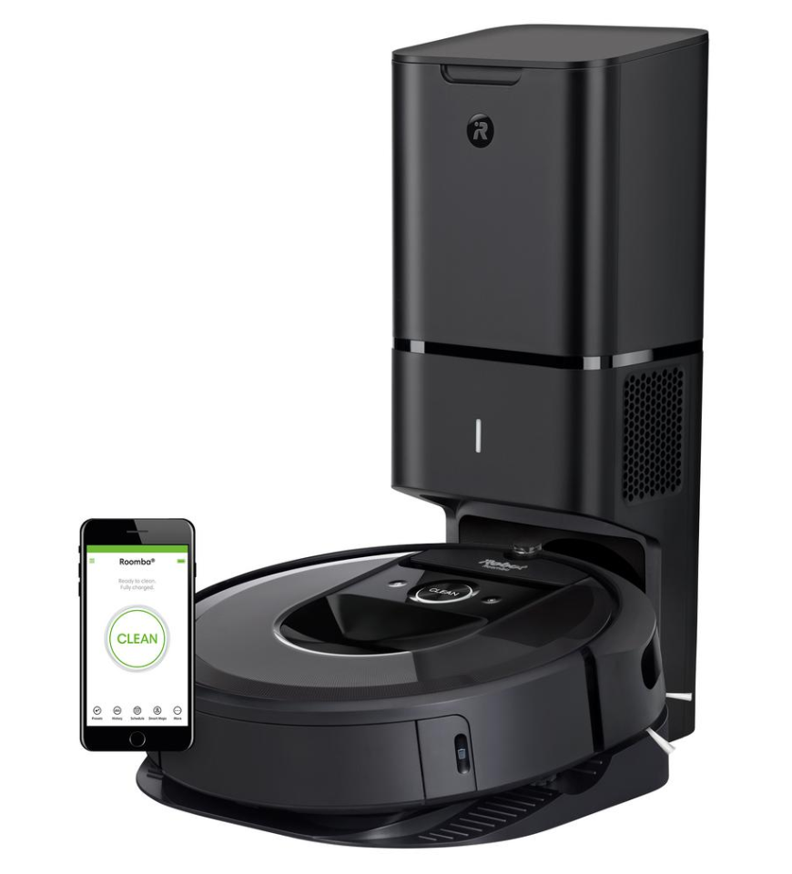
Q5 How likely are you to use a bathroom robot, which is similar to a roomba to clean your bathroom?
o Extremely likely (1)
o Somewhat likely (2)
o Neither likely nor unlikely (3)
o Somewhat unlikely (4)
o Extremely unlikely (5)
Q6 Compared to your regular bathroom cleaning frequency, if you have the robot, how many more times would you clean it?
o The same amount (1)
o 1 time (2)
o 1-3 times more (3)
o 4-6 times more (4)
o 7-10 times more (5)
Q7 What features would you like the bathroom robot cleaner to have? (Check all that apply)
▢ Vacuum (1)
▢ Soap dispenser (2)
▢ Mop (3)
▢ Sponge (4)
▢ Brush to scrub (5)
▢ Multiple surface cleaner/Disinfectant (6)
▢ Germ Detector (7)
▢ Automatic Dirt and Dust Dispenser (8)
Q8 What price range would you be willing to pay for the bathroom robot cleaner?
o Less than $600 (1)
o $600-$800 (2)
o $900-$1200 (3)
o $1300-$1600 (4)
o More than $1600 (5)
Q9 What age group do you best fit into?
o 18-24 (1)
o 25-32 (2)
o 33-38 (3)
o 39-44 (4)
o 44+ (5)
Q10 Which of the following sex identities best fits you?
o Male (1)
o Female (2)
o Intersex (3)
o Other (4)
o Prefer Not to Answer (5)
Q11 What is your marital status?
o Single (1)
o Married (2)
o Divorced (3)
o Prefer Not to Answer (4)
End of Block: Default Question Block
Colombia
BathBot Survey
Start of Block: Default Question Block

Q1 ¿Qué tan probable es que usted contrate a alguien para limpiar su baño?
o Definitivamente si (1)
o Probablemente si (2)
o Indeciso (3)
o Probablemente no (4)
o Definitivamente no (5)
Q2 ¿En promedio cuantas veces a la semana limpia su baño?
o Menos de 1 vez por semana (1)
o 1-3 veces por semana (2)
o 4-6 veces por semana (3)
o 7-10 veces por semana (4)
o Más de 10 veces por semana (5)
Q3 ¿Normalmente que productos usa para limpiar su baño? (Marque todas las que apliquen)
▢ Jabón (1)
▢ Blanqueador (2)
▢ Desinfectante (3)
▢ Esponja (4)
▢ Toallas (5)
▢ Limpiador multiuso (ej: Fabuloso, Mr.Musculo) (6)
Q4
En la siguiente imagen se muestra el iRobot Roomba, el cuál ayuda a los usuarios a limpiar sus hogares a un precio de $949USD con la capacidad de desechar la basura y el polvo que recoge en una bolsa.

Q5 ¿Que tan probable es que usted use un Robot similar al iRobot Roomba para el que limpie su baño?
o Definitivamente si (1)
o Probablemente si (2)
o Indeciso (3)
o Probablemente no (4)
o Definitivamente no (5)
Q6 En comparación con la frecuencia con la que usted actualmente limpia su baño, si tuviera el robot para el baño, ¿cuantas más veces lo limpiaría?
o La misma cantidad de veces (1)
o 1 vez más (2)
o 1-3 veces más (3)
o 4-6 veces más (4)
o 7-10 veces más (5)
Q7 ¿Qué características le gustaría que tuviera el robot para limpiar su baño? (Marque todas las que apliquen)
▢ Aspiradora (1)
▢ Dispensador de jabón (2)
▢ Trapeadora (3)
▢ Esponja (4)
▢ Cepillo para restregar (5)
▢ Limpiador para múltiples superficies / desinfectante (6)
▢ Detector de gérmenes (7)
▢ Dispensador automático de polvo y desechos (8)
Q8 ¿Qué rango de precio estaría dispuesto a pagar por el robot para limpiar su baño?
o Menos de $600 USD (1)
o $600-$800 USD (2)
o $900-$1200 USD (3)
o $1300-$1600 USD (4)
o Más de $1600 USD (5)
Q9 ¿Cuál es su grupo de edad?
o 18-24 (1)
o 25-32 (2)
o 33-38 (3)
o 39-44 (4)
o 44+ (5)
Q10 ¿Con cuál sexo se identifica?
o Masculino (1)
o Femenino (2)
o Intersexo (3)
o Otro (4)
o Prefiere no responder (5)
Q11 ¿Cuál es su estado civil?
o Soltero(a) (1)
o Casado(a) (2)
o Divorciado(a) (3)
o Prefiere no responder (4)
End of Block: Default Question Block

D: Financial Projections
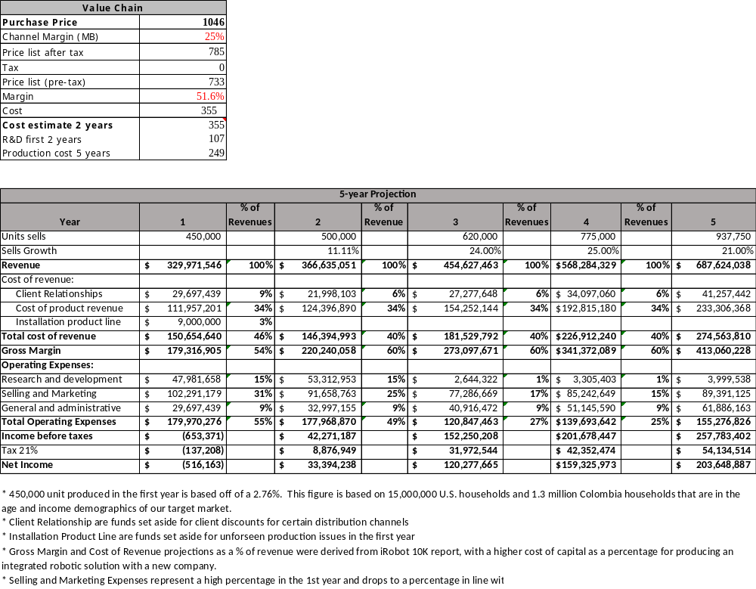

E: References

Average Salary Survey, Colombia. (2018, December 8). Retrieved from Average Salary Survey: https://www.averagesalarysurvey.com/colombia
Bedford, M. (2018, December 04). iRobot and Google Collaborate to Advance the Next-Generation Smart Home. Retrieved from iRobot: http://investor.irobot.com/news-releases/news-release-details/irobot-and-google-collaborate-advance-next-generation-smart-home
DANE. (2018, December 7). Retrieved from Estimaciones 198502005 y proyecciones 2005-1010 de hogares nacional y departamental por area: https;//www.dane.gov/co/files/investigaciones/poblacion/proyepobla06__10/hogares_viviendas_1985-2020.xls
Framil, L. (2018, March 08). Here's why Latin Amaericans will thrive in the age of the robots. World Economic Forum. Retrieved December 03, 2018, from https://www.weforum.org/agenda/2018/03/here-s-why-latin-americans-will-thrive-in-the-age-of-the-robots/
Herrera, M. (2018). Cae contratacion de empleadas domesticas en Columbia. Economia. Retrieved from https://www.rcnradio.com/economia/cae-contratacion-de-empleadas-domesticas-en-colombia
Karcher. (2018). Consumer preferences regarding household cleaning tools, supplies and support options in the United States as of 2018. statista. Retrieved from https://www-statista-com.esearch.ut.edu/statistics/894312/household0cleaning-preferences-in-the-us/.
Mislinski, J. (2018, October 16). U.S. Household Incomes, a 51 Year Perspective. Retrieved from Advisor Perspectives: https://www.advisorperspectives.com/dshort/updates/2018/10/16/u-s-household-incomes-a-51-year-perspective
(2017). Occupational Employment and Wages, May 2017. Bureau of Labor Statistics. Retrieved December 04, 2018, from https://www.bls.gov/oes/2017/may/oes372012.htm
Salario minimo para 2018 se definio en 781.242 pesos. (2017). Portafolio. Retrieved December 02, 2018, from https://www.portafolio.co/economia/salario-minimo-2018-es-de-781-242-pesos-512944
Smith, A., & Anderson, M. (2016). Online Shopping and E-Commerce. Pew Research Center.
Varela, C. (2014). La dificil tarea de encontrar na empleada interna. Nota Ciudadana. Retrieved December 6, 2018, from https://www.las2orillas.co/la-dificil-tarea-de-encontrar-una-empleada-interna/

